Framework Needed

1. Angular -- > 15.2.10 to install use command

For global --> **npm install -g @angular/cli@15.2.10/**

For local --> **npm install @angular/cli@15.2.10**

1. Node -- > 16.19.0 to download refer link [**https://nodejs.org/en/blog/release/v16.19.0**](https://nodejs.org/en/blog/release/v16.19.0)

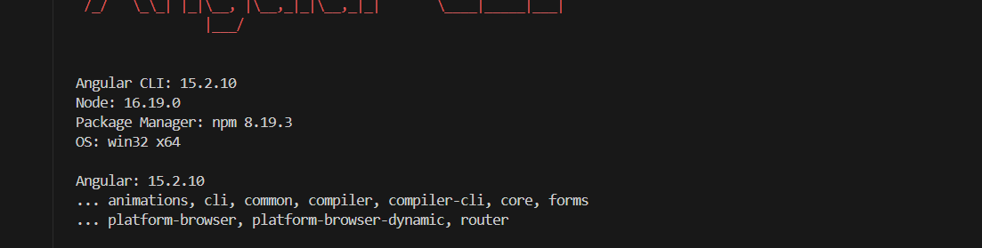

Set up application

1) Copy micro- application folder from User management folder into required UI project

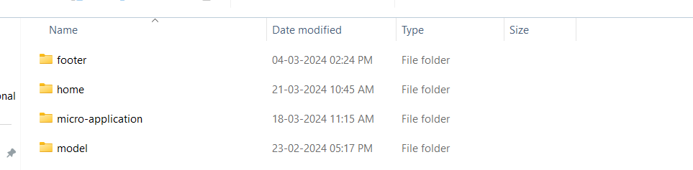

1. Import micro-application module into app module

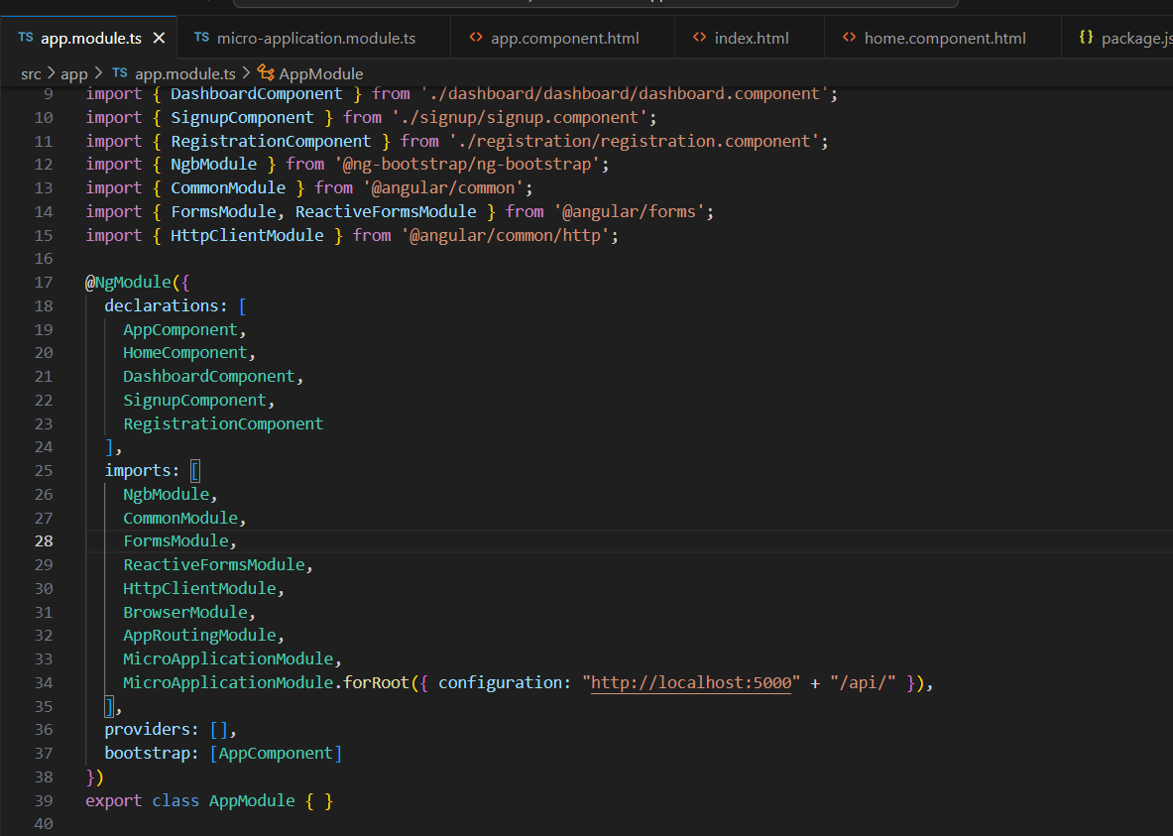

1. Add following path the work with micro-application feature

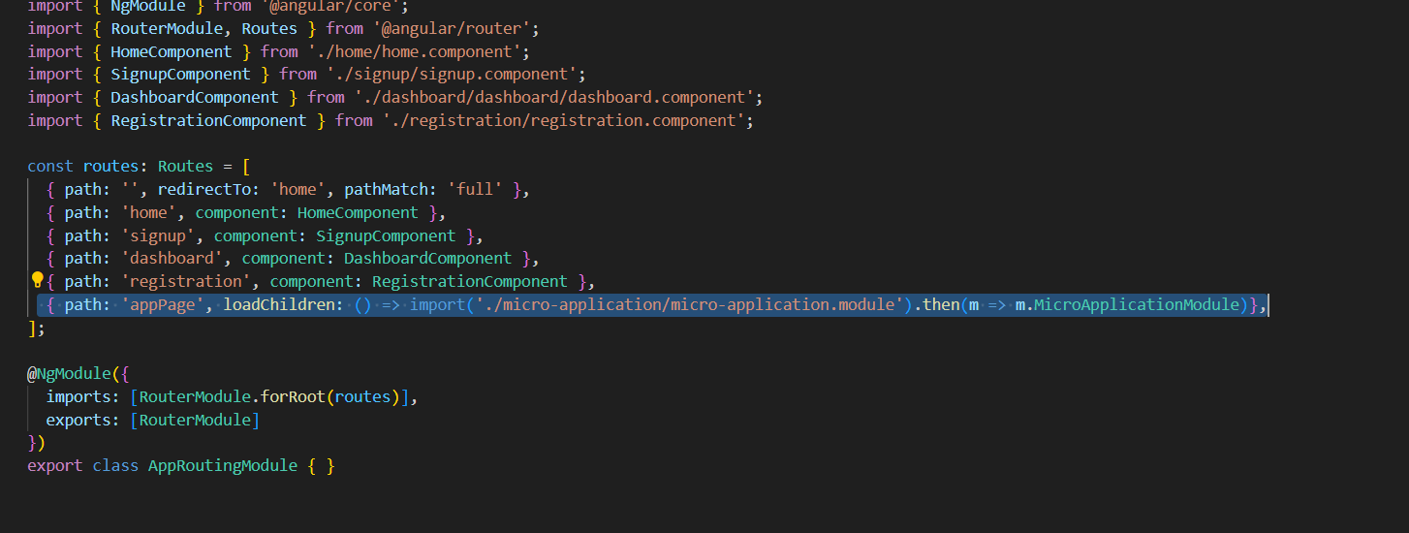

1. Install following package which are needed for micro-application module

**Package.json**

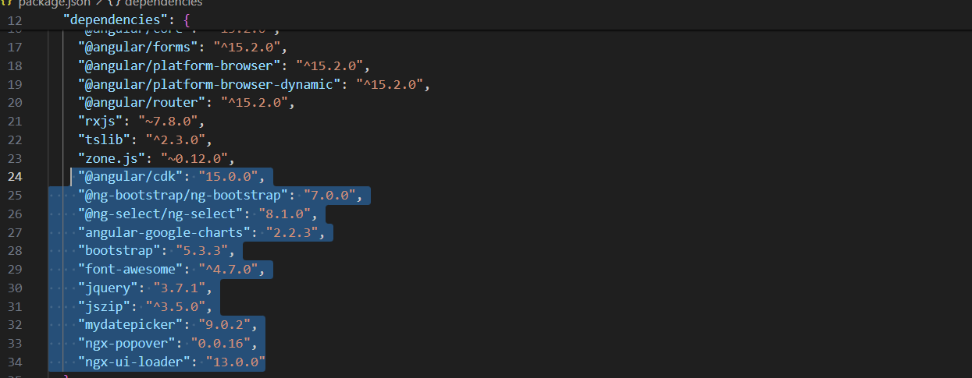

**Micro-Application.module.ts uses above packages**

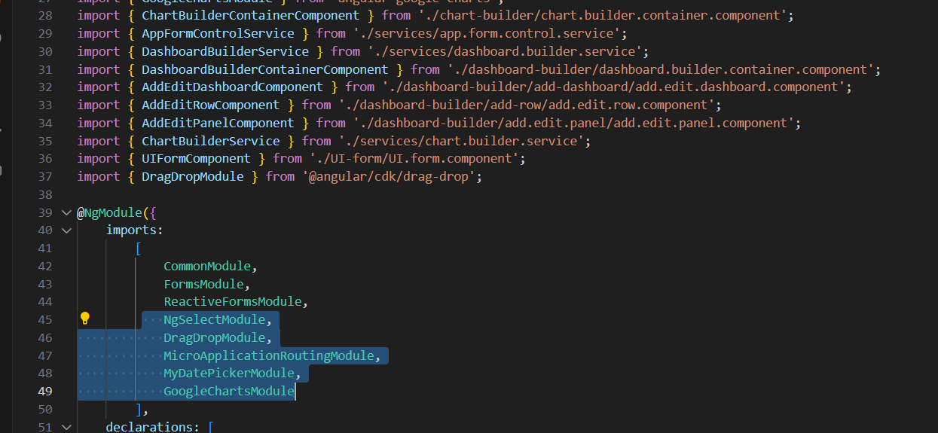

1. Import following modules in app module too

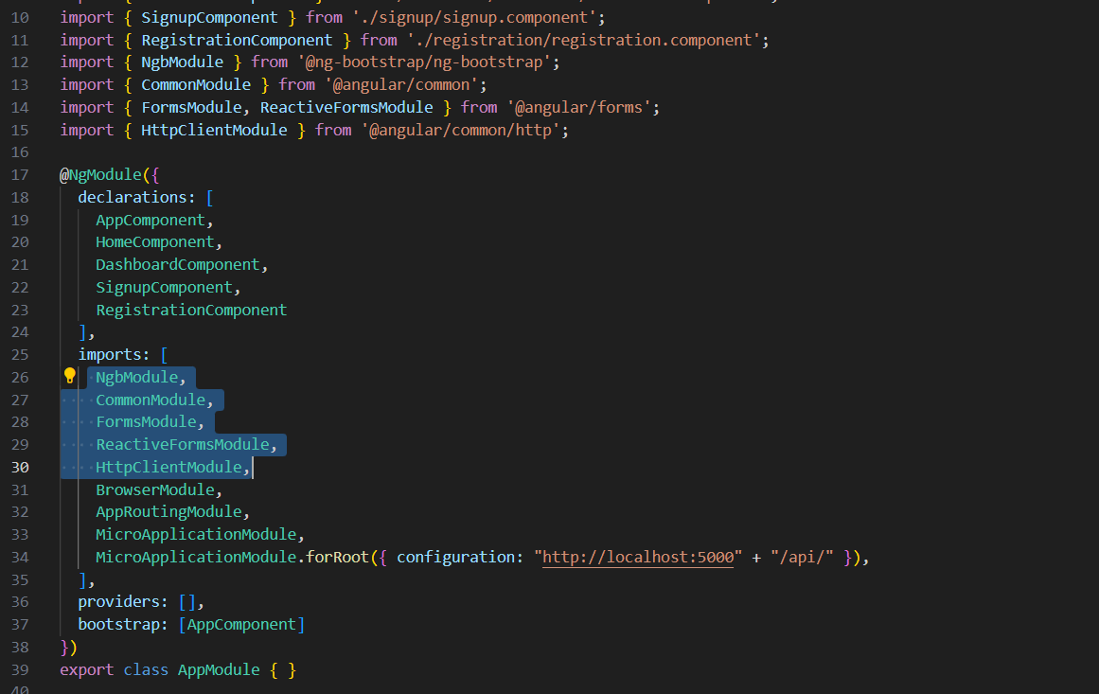

1. To install node module refer <https://www.npmjs.com/package> website

Suppose we have to install mydatepicker of 9.0.2 then

### Go to <https://www.npmjs.com/package>

* In search enter keyword mydatepicker
* Click on versions
* From version list click on 9.0.2

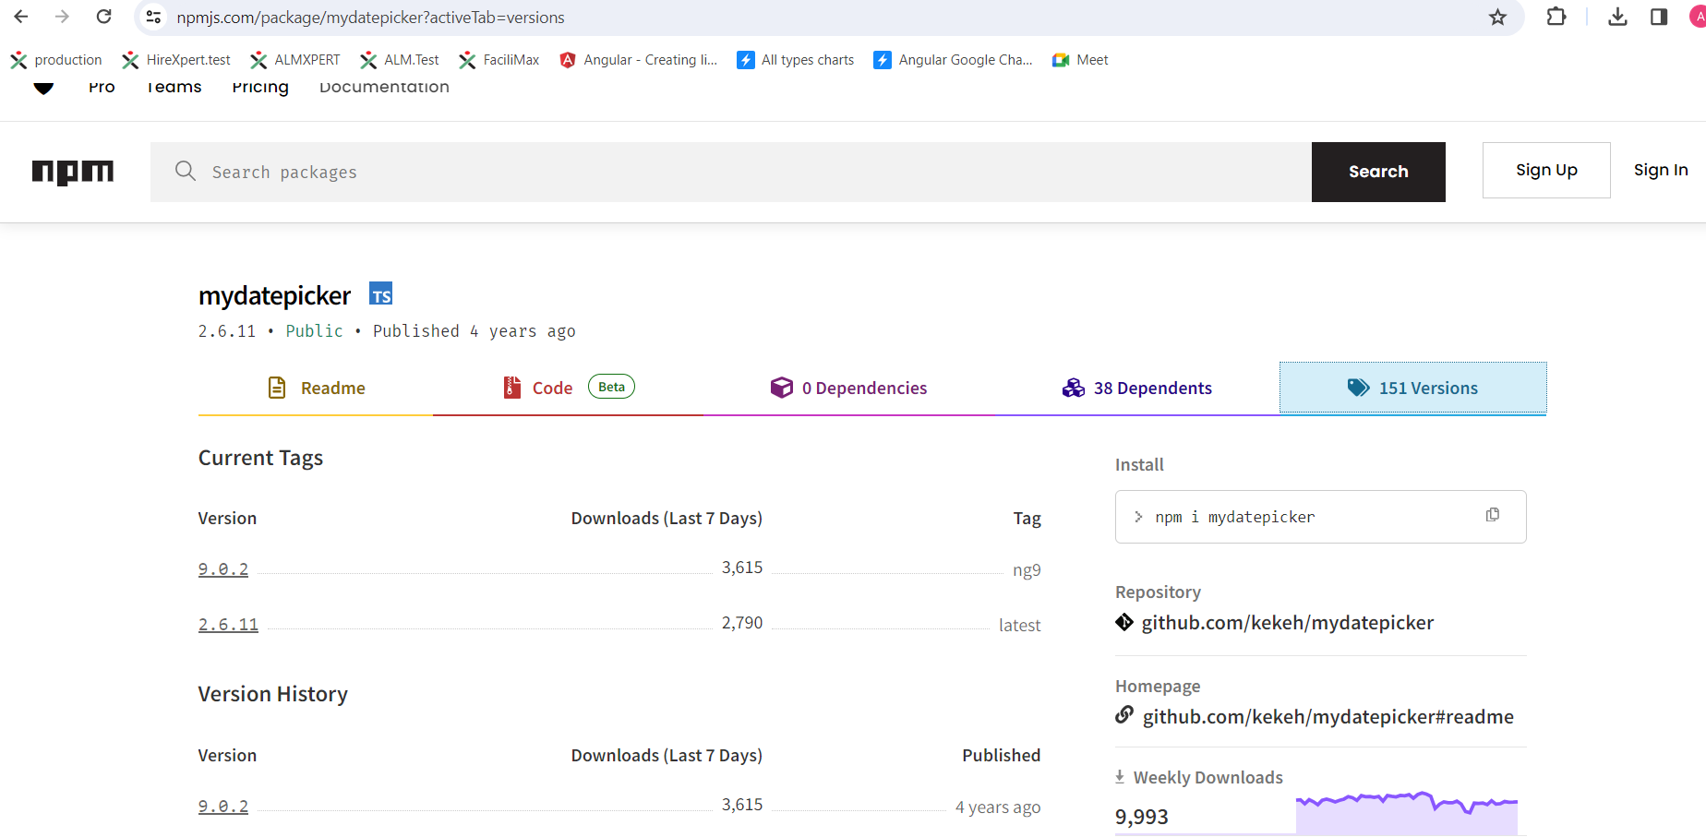

* On click you can copy command to install package

